|  |
| --- |
| **Software Requirements Specification**  **Husam Nizar ALsufi (201610055)**  **Murad Zaydoun Alhijawi (201610116)**  **Ahmad Abdulkareem Al-masri (201710670)**  **Mohanad Abdalhamed Aljondi (201620262)**  **Table of Contents**  1. Introduction ............................................................................................................................................... 1  1.1 Purpose ................................................................................................................................................ 1  1.2 Scope ................................................................................................................................................... 1  1.3 Definitions, acronyms, and abbreviations ........................................................................................... 1  1.4 References ........................................................................................................................................... 2  2. Overall description .................................................................................................................................... 4  2.1 Product perspective ............................................................................................................................. 4  2.2 Product functions ................................................................................................................................ 4  2.3 User characteristics ............................................................................................................................. 5  2.4 Constraints .......................................................................................................................................... 5  2.5 Assumptions and dependencies .......................................................................................................... 5  2.6 Apportioning of requirements ............................................................................................................. 6  3. Specific requirements ................................................................................................................................ 7  3.1.1 User interfaces ............................................................................................................................. 7  3.1.2 Hardware interfaces ..................................................................................................................... 8  3.1.3 Software interfaces ....................................................................................................................... 8  3.1.4 Communications interfaces .......................................................................................................... 9  3.2 Functional requirements ...................................................................................................................... 9  3.2.1 User Class 1 - The User ............................................................................................................... 9  3.2.2 User Class 2 - Restaurant Owner ............................................................................................... 14  3.2.3 User Class 3 - Administrator ...................................................................................................... 18  3.3 Performance requirements ................................................................................................................ 21  3.4 Design constraints ............................................................................................................................. 23  3.5 Software system attributes ................................................................................................................ 23  4. Prioritization and Release Plan ............................................................................................................... 27  4.1 Choice of prioritization method ........................................................................................................ 27  Appendix I: Selection for Cost-Value Approach ........................................................................................ 29  Appendix II: Prioritization Result of 10 selected Requirements Using Cost-Value Approach .................. 32  Appendix III: Five-Way Priority Scheme ................................................................................................... 36  Appendix IV: Release Plan ......................................................................................................................... 47  Appendix V: I-star ...................................................................................................................................... 55 |

**Table 1 - Definitions**

**1.Introduction**

This section gives a scope description and overview of everything included in this SRS document. Also, the purpose for this document is described and a list of abbreviations and definitions is provided.

**1.1Purpose**

**The purpose of this document is to give a detailed description of the requirements for the “Watch App”. It will illustrate the purpose and complete declaration for the development of system. It will also explain system constraints, interface and interactions with client. This document is primarily intended to be proposed to a customer for its approval and a reference for developing the first version of the system for the development team.**

**1.2 Scope**

**the "Watch” is a GPS-based mobile application which helps parents to check their kid’s status based on the user’s current position, health status and other specification like bus map, vacations request and check student attendance and Absence. The application will be free to download to mobile phone from application store with full service if customer buy the watch. Parents and kids can provide their information by using the web-portal. This information will control authorize access and information displayed for the parents, kids, school management and bus driver A school management also uses the web-portal to check if the information accurate. The school management can, for instance, verify kids’ information and manage buses transitions Furthermore, the software needs Internet, GPS connection and watch to fetch and display results. All system information is maintained in a database, which is located on a web-server. The software also interacts with the GPS-Navigator software which is required to be an already installed application on the user’s mobile phone. By using the GPS-Navigator, users can view desired location on a map, bus map and other services like healthy state and move between them easily. The application also has the capability of representing both summary and detailed information., Like kids health record and check in check out time for month.**

**1.3 Definitions, acronyms, and abbreviations**

**Table 1 - Definitions**

|  |  |
| --- | --- |
| **Term** | **Definition** |
| **User** | **Someone who interacts with the mobile phone application** |
| **watch** | **hand watch that contain sensor and heart beat device connecting with watch application.** |
| **school management** | **people who has own school and they're part of the application.** |
| **Web-Portal** | **A web application which present special facilities for owner.** |
| **GPS Global** | **Positioning System** |
| **GPS-Navigator** | **An installed software on mobile phone which could provide GPS connection and data, show locations on map.** |
| **Application Store** | **An installed application on mobile phone which helps user to find new compatible applications with mobile phone platform and download them from Internet.** |

**1.4 References**

M.alataye. Class Lecture, Topic "Final Project”, Faculty of Software Engineering, Philadelphia University Jordan, Jaresh, Nov.30,2019

**1.5 Overview**

The remainder of this document includes three chapters and appendixes. The second one provides an overview of the system functionality and system interaction with other systems. This chapter also introduces different types of stakeholders and their interaction with the system. Further, the chapter also mentions the system constraints and assumptions about the product.

The third chapter provides the requirements specification in detailed terms and a description of the different system interfaces. Different specification techniques are used in order to specify the requirements more precisely for different audiences.

The fourth chapter deals with the prioritization of the requirements. It includes a motivation for the chosen prioritization methods and discusses why other alternatives were not chosen.

The Appendixes in the end of the document include the all results of the requirement prioritization and a release plan based on them.

**2. Overall description**

**This section will give an overview of the whole system. The system will be explained in its context to show how the system interacts and introduce the basic functionality of it. It will also describe what type of stakeholders that will use the system and what functionality is available for each type. At last, the constraints and assumptions for the system will be presented**

**2.1 Product perspective figure 1**

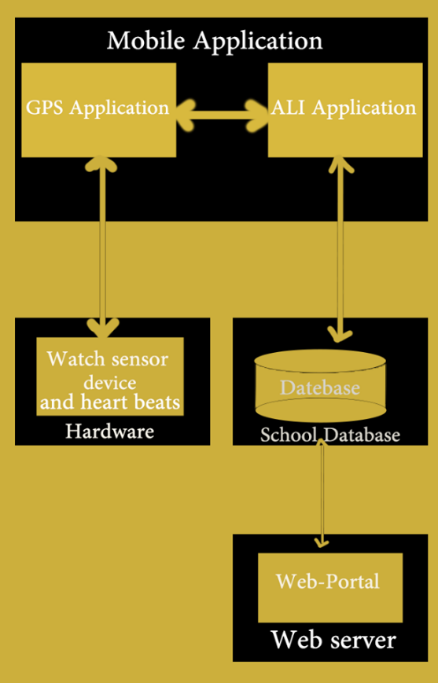

**This system will consist of two parts: one mobile application and one web portal. The mobile application will be used to find kids and view information about them while the web portal will be used for managing the information about the kids and the system as a whole.**

**The mobile application will need to communicate to a GPS application within the mobile phone, which in turn communicates with a physical GPS device to find the location of the user, see Figure 1. The GPS will provide the mobile application with locations of both the kids and parents and the distance between them, but it will also provide maps and the functionality to display the application’s data on the map. The functionality provided by the GPS will be embedded into the application in order make user able to use the functions in the application in a seamlessly manner.**

**Since this is a data-centric product it will need somewhere to store the data. For that, a database will be used. Both the mobile application and web portal will communicate with the database, however in slightly different ways. The mobile application will only use the database to get data while the web portal will also add and modify data. All of the database communication will go over the Internet.**

The mobile application has some restrictions about the resource allocation. To avoid problems with overloading the operating system the application is only allowed to use 200 megabytes of memory while running the application. The maximum amount of hard drive space is also 200 megabytes.

**2.2 Product functions**

**With the mobile application, the users will be able to search for kids. The result will be based on Validity reach. There are several criteria for result view. and it will be possible for the administrator (school management) of the system to manage the options for those criteria that have that. The result of the search will be viewed either in Schematic healthy model and show location in a map., depending on what criteria included in the search.**

**If parents send vacation request to school due Application, the Application will send Report to school management and blocking kid location for bus driver Throughout the holidays then back again.**

**The Schematic healthy model view will have two part first is healthy condition with Centenary scale second is Schematic healthy Graphic model. Application should matching the search with target and show location on map with personal information, so the user can know the details.**

**The map view will show each kid location as a pin on the map as well as the user’s own location for school. In both views the users will be able to either see a kid as target destination or get information how to get there for bus driver, or view the information of a specific address,** **bus driver will checks in for very kids by read barcode that on watch, using mobile camera ,anyone not owns barcode is not allowed to board the bus.**

**The web portal will provide functionality to manage the system and information. It will also provide information about the system, for example show when there is a new update.**

**2.3 User characteristics**

**There are three types of users that interact with the system: School, Student and Bus Driver. Each of these three types of users has different use of the system so each of them has their own requirements**

**The school users can only use the application to find kids. This means that the user have to be able to search for kids, check of attendance and absence and see healthy condition. In order for the users to get a relevant search result there are multiple criteria the users can specify and all results matches all of those.**

**The student users can use the application to navigate to kids. This means that the user have to be able to check health for kids, and check of view location ,and view bus map In order for the users to get a relevant search result there are multiple criteria the users can specify and all results matches all of those.**

**2.4 Constraints**

**2.5 Assumptions and dependencies**

**2.6 Apportioning of requirements**

**3. Specific requirements**

This section contains all of the functional and quality requirements of the system. It gives a detailed description of the system and all its features.

**3.1 External interface Requirements**

This section provides a detailed description of all inputs into and outputs from the system. It also gives a description of the hardware, software and communication interfaces and provides basic prototypes of the user interface.

**3.1.1 User interfaces**

A first-time user of the mobile application should see the **All User** page when he/she opens the application, see **Figure 1.** If the user has not registered, he/she should be able to do **sing up** that on the **log in** page see **Figure 2** . If the user is not a first-time user, he/she should be able to see the **Your Profile** page directly when the application is opened, see **Figure 3**. Here the user chooses the type of service he/she wants to conduct. Every user should have a profile page where they can edit their e-mail address, phone number and password . Also, The “Bell” icon shows where the user can click to **Notifications** to his/her profile page. If the user click in **Sing up** button that open the **Registered** page see **Figuer 4**.

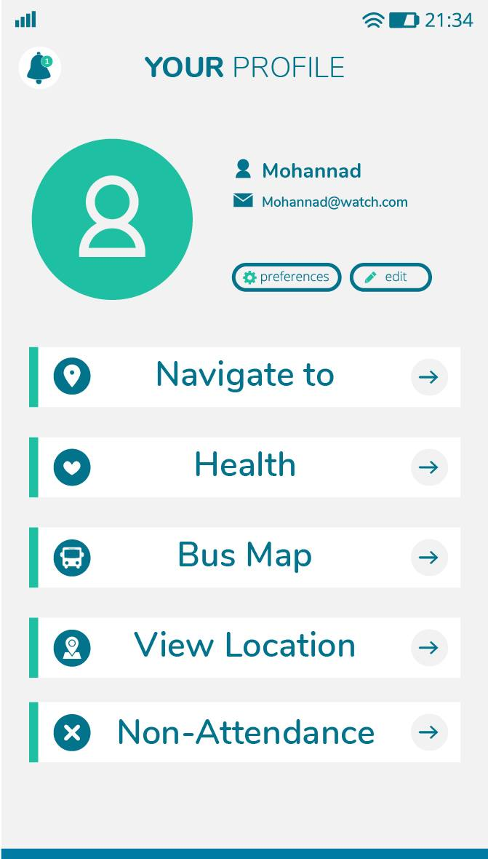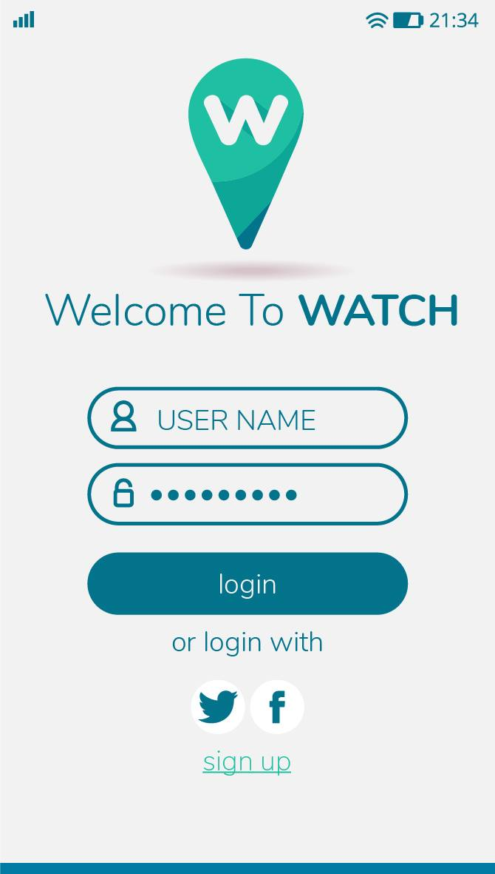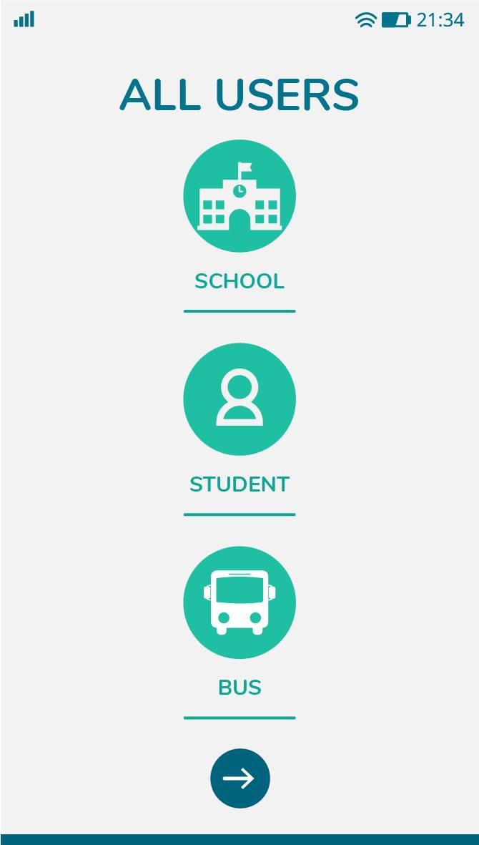

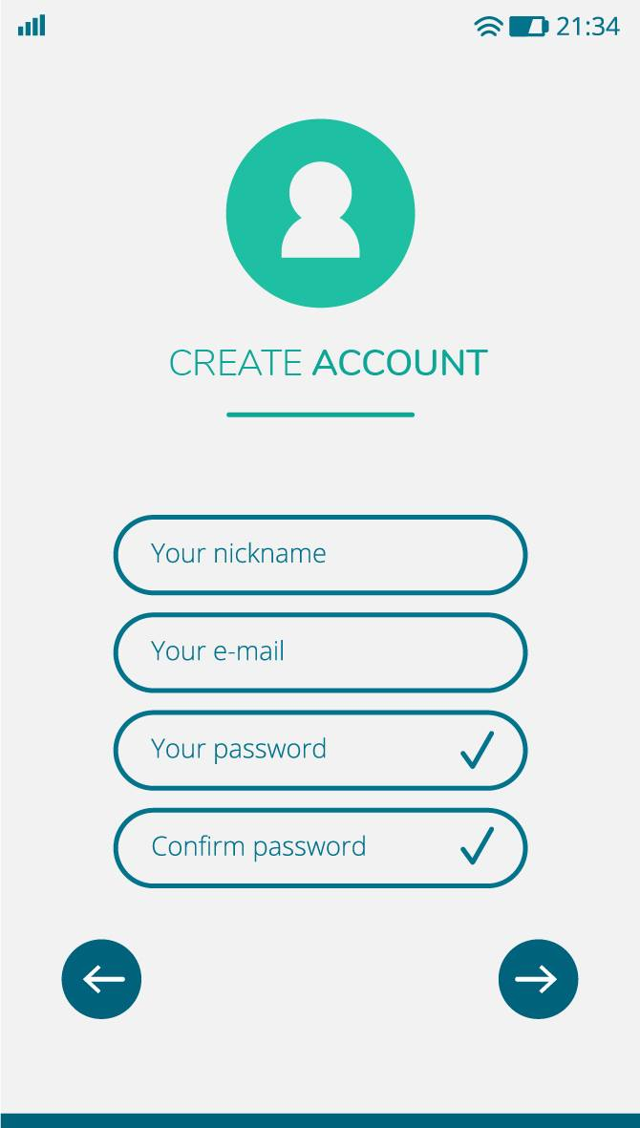

**Figure 1. Figure 2 Figure 3 Figure 4**

**In Figure 3**, the list view for the service is shown. When a user click the **Navigate to** service it’s open the **navigate to** page see **Figure 5**, this view should be the default one. Also, When the user choose the second service that open the **Health page** see **Figure 6.** Also, The third service that allows the users to see the location of Buses track in **Bus Map** see **Figure 7.** The Fourth service also allows the users to see the location of there children in **View Location** see **Figure 8.** The Five service is if the users does not want to send their children to school, It’s allows to them to enter the date of absence and the reason for absence in **Non-attendance** page see **figure 9**.

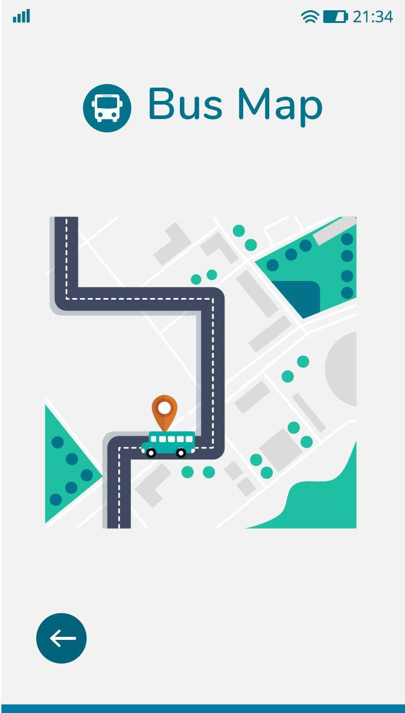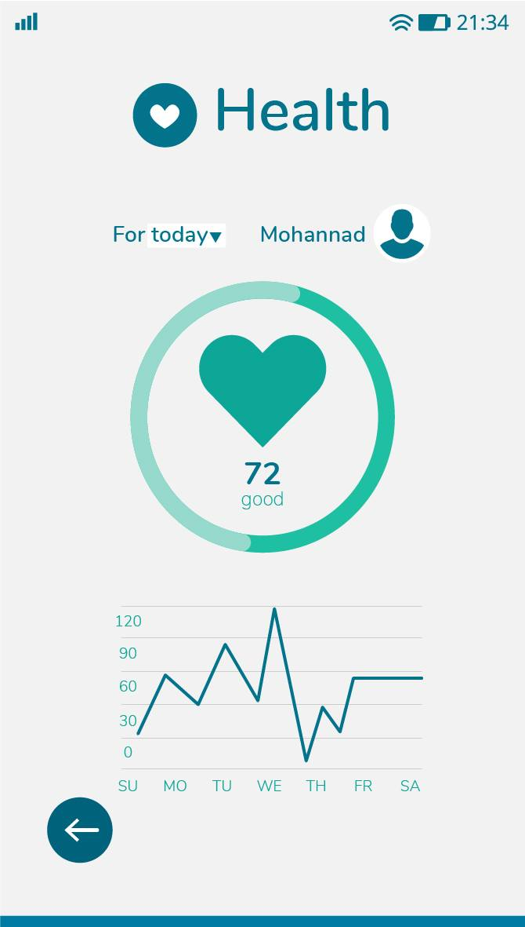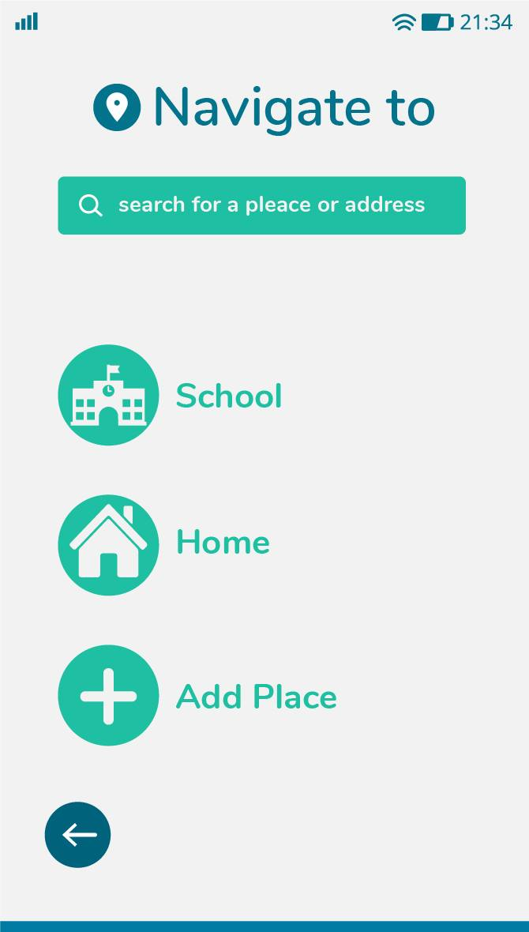

**Figure 5 Figure 6 Figure 7**

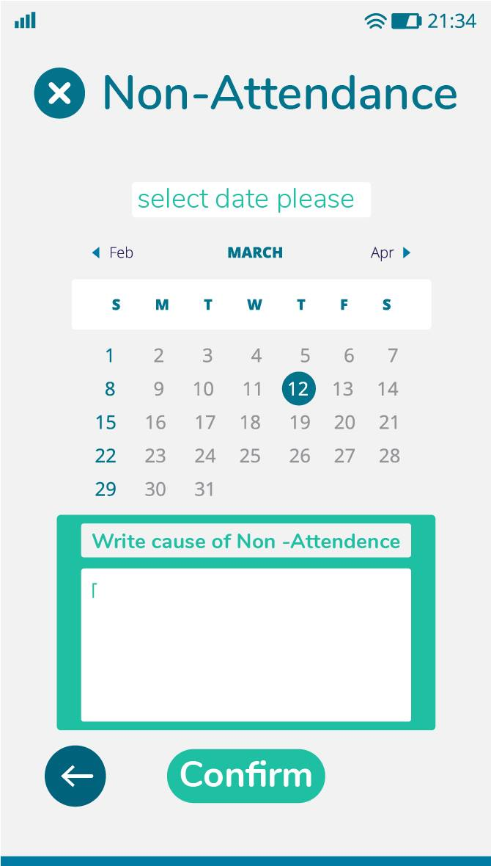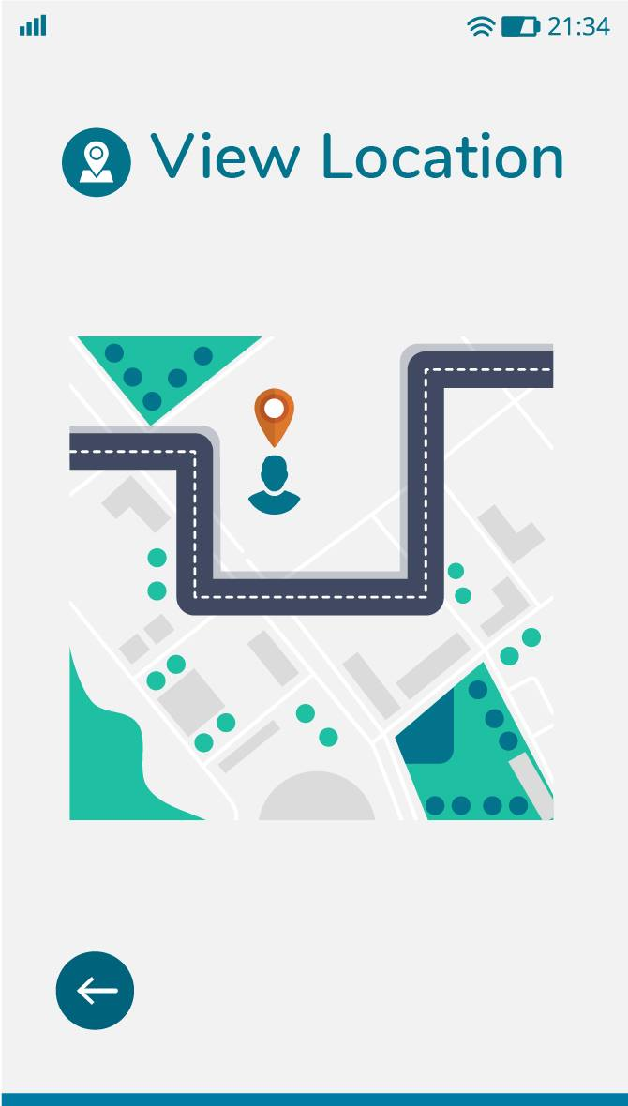

**Figure 8 Figure 9**

If the user chooses from **Figure 1 Bus**, he will log in as a bus driver, then the application will be change to bus driver screen.

**Figure 1**. Here the user (Driver) es the type of service he/she wants to conduct. User (Driver) should have a profile page where they can edit their e-mail address, phone number and password and he can see **star rating** obtained after completion of each flight. Also, “The Bell” icon shows where the user can click to **Notifications** to his/her profile page. If the user Click in button **Q r Code Student** that open page see **Figure 2**.

If the user Click in button **Student Home** that open page see **Figure 3**.

If the user Click in button **Student On Board** that open page see **Figure 4.**

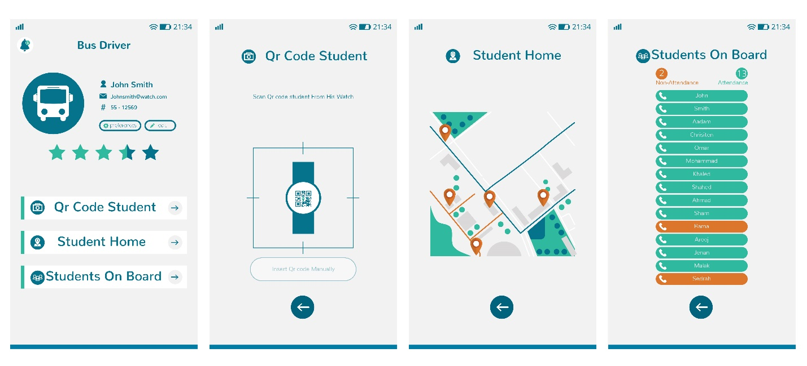

**Figure 1 Figure2 Figure 3Figure 4**

**3.1.2 Hardware interfaces**

Since neither the mobile application nor the web portal have any designated hardware, it does not have any direct hardware interfaces. The physical GPS is managed by the GPS application in the mobile phone and the hardware connection to the database server is managed by the underlying operating system on the mobile phone and the web server.

**3.1.3 Software interfaces**

The mobile application communicates with the GPS application in order to get geographical information Figure 5 – Bus map Figure7 – View Location Figure 8 – about where the user is located and the visual representation of it, and with the database in order to get the information about the Children and The Buses. The communication between the database and the web portal consists of operation concerning both reading and modifying the data, while the communication between the database and the mobile application consists of only reading operations.

**3.1.4 Communications interfaces**

The communication between the different parts of the system is important since they depend on each other. However, in what way the communication is achieved is not important for the system and is therefore handled by the underlying operating systems for both the mobile application and the web portal.

**3.2 Functional requirements**

This section includes the requirements that specify all the fundamental actions of the software system.

**3.2.1 User Class 1- The User**

**3.2.1.1 Functional requirement1.1**

ID: FR1

TITLE: Download mobile application

DESC: A user should be able to download the mobile application through either an application store or similar service on the mobile phone. The application should be free to download.

RAT: In order for a user to download the mobile application.

**3.2.1.2 Functional requirement 1.2**

ID: FR2

TITLE: Download and notify users of new releases DESC: When a new/updated version or release of the software is released, the user should check for these manually. The download of the new release should be done through the mobile phone in the same way as downloading the mobile application. RAT: In order for a user to download a new/updated release.

**3.2.1.3 Functional requirement 1.3**

ID: FR3

TITLE: User registration - Mobile application DESC: Given that a user has downloaded the mobile application, then the user should be able to register through the mobile application. The user must provide user-name, password and e-mail address. The user can e to provide a regularly used phone number.

RAT: In order for a user to register on the mobile application.

**3.2.1.4 Functional requirement 1.4**

**ID: FR4**

TITLE: User log-in - Mobile application

DESC: Given that a user has registered, then the user should be able to log in to the mobile application.

The log-in information will be stored on the phone and in the future the user should be logged in automatically.

RAT: In order for a user to register on the mobile application.

**3.2.1.5 Functional requirement 1.5**

**ID: FR5**

TITLE: Retrieve password DESC: Given that a user has registered, then the user should be able to retrieve his/her password by email.

RAT: In order for a user to retrieve his/her password.

**3.2.1.6 Functional requirement 1.6**

ID: FR6

TITLE: Mobile application-select User

DESC: Since the user is registered in the mobile app, it should be the first page that appears

ALL User page. The user should be able to e the account that determines his membership in the App, according to several options that appear before him.

The options are those who set his authority to use the App, Destination, User type specified. The user should be able to select multiple options in one suitable choice.

RAT: In order to select User

**3.2.1.7 Functional requirement 1.7**

ID: FR7

TITLE: Mobile application – View Location

DESC:

location of children can be viewed on a map. , the relevant and closest children according

to the user’s position are shown.

A specific pin will represent a specific children location. On each pin should be maximally 1 results displayed. The map view should have a default zoom.

RAT: The way results are displayed in a map.

**3.2.1.8 Functional requirement 1.8**

**ID: FR8**

TITLE: Mobile application - Navigation to

DESC:

A user should be able to select a pin on a map or an element on a list. When a selection is made,

the location of the where they want the children should be sent to the mobile phone’s GPS-navigation program. The user

should then be navigated to the destination. When the destination is reached, a user should be able to go

back to the Your profile page on the mobile application.

RAT: To navigate a user to a chosen location.

**3.2.1.9 Functional requirement 1.9**

**ID: FR9**

TITLE: Mobile application - Switch Service

DESC:

A user should be able to switch between Service and a list service for all service options.

RAT: In order for a user to switch between service.

**3.2.1.10 Functional requirement 1.10**

**ID: FR10**

TITLE: Mobile application-Health

DESC:A user should be able to see the status of there children, In order Daily, weekly, monthly and yearly. And knowing the heart beats if they are regular or not by giving a percentage of that Like ( Good , Normal , Bad , Dangerous ).

RAT: In order to know the children status.

**3.2.1.11 Functional requirement 1.11**

**ID: FR11**

TITLE: Mobile application-Bus Map

DESC:

It is possible through the Bus Map page, if the bus driver loads the students into the bus, the application will send a notification to the parents that the children boarded the bus that will activate Bus Map option, and through this option they can know where the bus is located on the map if the bus has arrived to the specific location For the home, the app will also send a notification to the parents that the child has arrived, and then the Bus Map feature stops.

RAT: In order to see the bus location and if the children boarded .

**3.2.1.12 Functional requirement 1.12**

**ID:FR12**

TITLE: Mobile application- Non-attendance

DESC:

This option allows users if they want their son not to go to school, they will specify the date by which the child will be absent, and then a menu appears to them to determine what is the reason for the absence after this option is made, the application will send a notification to the school that the child will be absent on the date that was specified Through users with the possibility to know the reason for the absence

RAT: In order to told the school the reason of absence.

**3.2.1.13 Functional requirement 1.13**

**ID: FR13**

TITLE: Mobile application- Your Profile

DESC:

On this page, the user will see his personal information, and he can amend it if there is a desire to change some information or add some of it, and he will also have services that will enable him to practice his activities on the application (Navigate to, Health, Bus Map, View location, Non-attendance).

RAT: In order to do the activities that he/she wants.

**3.2.2 User Class 2 school Owner**

**3.2.2.1 Functional requirement 2.1**

ID: FR22

Feature: Create an account

In order to create an account

A school owner

Should register on the application-portal

Scenario: Required information for registration

Given the school owner wants to create an account

And the school owner does not have an account

When the school owner registers on the web-portal by providing (nick- name and password And

e-mail address, confirm password)

Then the school owner should be able to apply for verification

Scenario: Full information for registration

Given the School owner wants to create an account

And the School owner does not have an account

When the School owner registers on the web-portal by providing

User-Name

And password

And address

And e-mail address

Then the School owner should be able to apply for verification

Scenario: Confirmed registration

Given the School owner has applied for verification

And has not received a confirmation e-mail after registration

When the

School owner receives a confirmation e-mail

Then the School owner should be able to log in

**3.2.2.2 Functional requirement 2.2**

ID: FR23

Feature: school owner log-in

In order to use the system

A School owner

Should be logged in to the web-portal

Scenario: Successful log-in

Given the school owner wants to log in

When the school owner logs in with his/her account

Then the school owner should be logged in as a school owner

Scenario: Retrieve password

Given the school owner wants to log in

And has lost the password

When the school owner enters his/her email address in the “Retrieve password” form

And submits the form

Then the school owner should receive an email containing the password

3.2.2.3 Functional requirement 2.3

ID: FR24

Feature: Manage information

In order to manage information

A school owner

Should be logged in to the Application-portal

Scenario: Show fields for managing information

Given the School owner is logged in

When the school owner wants to manage information

Then the school owner should be able to manage information in a form

Scenario: Filling in mandatory fields

Given the school owner wants to fill in the mandatory fields of the form

When the school owner provides

address

And e-mail address

And phone number

And school name

Then the school owner has filled the mandatory fields of the form

Scenario: Adding information with mandatory fields

Given the school owner has filled in the mandatory fields of the form

When the school owner submits the form

Then the information about the school should be added

Scenario: Adding information with mandatory and optional fields

Given the school owner has filled in the mandatory fields of the form 17

And filled in one or more optional fields of the form

When the school owner submits the form

Then the information about the school should be added

Scenario: Deleting information

Given the school owner is logged in

And information exists

When the school owner deletes information

Then the information should be deleted

Scenario: Editing information

Given the school owner is logged in

And information exists

When the school owner edits information

Then the information should be edited

3.2.2.4 Functional requirement 2.4

ID: FR25

Feature: school owner and student and driver Bus Selecting preferred language on the application-portal

In order to understand the application -portal

All user Should be able to select a preferred language for the application-portal

Scenario: Select English as preferred language

Given the All users want to select a preferred language

When the All users select English as a new language

Then the application-portal will show all text in English

Scenario: Select Arabic as preferred language

Given the All users want to select a preferred language

When the All users select Arabic as a new language

Then the web-portal will show all text in Arabic

**3.2.3 User Class 3 - Administrator**

**3.2.3.1 Functional requirement 3.1**

ID: FR26

Feature: Administrator log in

In order to administer the system an administrator Should be logged in to the application-portal

Scenario: Successful log-in

Given the administrator wants to log in When the administrator logs in with an administrator account Then the administrator should be logged in as an administrator

**3.2.3.2 Functional requirement 3.2**

ID: FR27

Feature: Verify school owner and student and driver bus

In order to allow a school owner to use the system

An administrator

Should be able to verify the school owner and student account and bus driver account

Scenario: Verify All users

Given the administrator is logged in

When the administrator verifies All users

Then the All users should be able to log in

And All users should be notified by a confirmation email

Scenario: Reject All users

Given the administrator is logged in

When the administrator rejects All users

Then All users should not be able to log in

And All users should be notified by a rejection email

**3.2.3.3 Functional requirement 3.3**

ID: FR28

Feature: Bus management

In order to obtain a list of students

Responsible

It should be able to manage the student by school.

The school has the right to determine the number of students

on the bus based on the size of the bus and distribute the students to the neighborhoods

Scenario: Add a new student

Given the administrator is logged in

When the administrator Add a new student

Then the new dish should be added to the list of students

Scenario: Delete a student

Given the administrator is logged in

When the administrator deletes a student

Then the deleted student should be removed from the list of students

**3.2.3.5 Functional requirement 3.5**

ID: FR30

Feature: Manage All users information

In order to manage All user information

An administrator Should be logged in to the application-portal

Scenario: Add student and bus driver information

Given the administrator is logged in

When the administrator adds to student and bus driver information

Then the information should be added to them

Scenario: Add student and bus driver information

Given the administrator is logged in

When the administrator adds to student and bus driver information

Then the information should be added to them

Scenario: Delete student and bus driver information

Given the administrator is logged in20

And information about a students or bus driver exists

When the administrator deletes the information

Then the information about the student or bus driver should be deleted

**3.3 Performance requirements**

The requirements in this section provide a detailed specification of the user interaction with the software and measurements placed on the system performance.

**3.3.1 Prominent search feature**

ID: QR1

TITLE: Prominent search feature

DESC: The search feature should be prominent and easy to find for the user.

RAT: In order to for a user to find the search feature easily.

**3.3.2 Usage of the search feature**

ID: QR2

TITLE: Usage of the search feature

DESC: The different search options should be evident, simple and easy to understand.

RAT: In order to for a user to perform a search easily.

**3.3.3 Usage of the result in the list view**

ID: QR3

TITLE: Usage of the result in the list view

DESC: The results displayed in the list view should be user friendly and easy to understand. Selecting an element in the result list should only take one click.

RAT: In order to for a user to use the list view easily.

**3.3.4 Usage of the result in the map view**

ID: QR4

TITLE: Usage of the result in the map view

DESC: The results displayed in the map view should be user friendly and easy to understand. Selecting a pin on the map should only take one click.

RAT: In order to for a user to use the map view easily

**3.3.5 Response time**

ID: QR6

TAG: Response Time

GIST: The fastness of the search

SCALE: The response time of a search

METER: Measurements obtained from 1000 searches during testing.

MUST: No more than 2 seconds 100% of the time.

WISH: No more than 1 second 100% of the time.

**3.4 Design constraints**

This section includes the design constraints on the software caused by the hardware.

**3.4.1 Hard drive space**

ID: QR10

TAG: Hard DriveSpace

GIST: Hard drive space.

SCALE: The application’s need of hard drive space.

METER: MB.

MUST: No more than 20 MB.

PLAN: No more than 15 MB.

WISH: No more than 10 MB.

MB: DEFINED: Megabyte

**3.4.2 Application memory usage**

ID: QR11

TAG: ApplicationMemoryUsage

GIST: The amount of Operate System memory occupied by the application.

SCALE: MB.

METER: Observations done from the performance log during testing

MUST: No more than 20 MB.

PLAN: No more than 16 MB

WISH: No more than 10 MB

Operate System: DEFINED: The mobile Operate System which the application is running on.

MB: DEFINED: Megabyte.

**3.5 Software system attributes**

The requirements in this section specify the required reliability, availability, security and maintainability of the software system.

**3.5.1 Availability**

ID: QR7

TAG: System Availability

GIST: The availability of the system when it is used.

SCALE: The average system availability (not considering network failing).

METER: Measurements obtained from 1000 hours of usage during testing.

MUST: More than 98% of the time.

PLAN: More than 99% of the time.

WISH: 100% of the time.

ID: QR22

TITLE: Internet Connection

DESC: The application should be connected to the Internet.

RAT: In order for the application to communicate with the database.

ID: QR23

TITLE: GPS Connection

DESC: The application should be connected to the GPS device.

RAT: In order for the application to get the users location, the map and to calculate the distance.